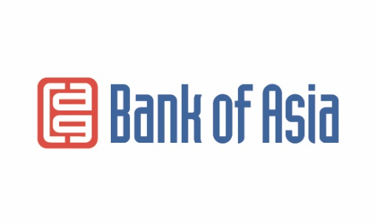

Required documents for obtaining the Express-250 loan

- Passport
- Spouse's passport
- Marriage certificate
- Guarantee of one person
- Salary certificate or business document
- Certificate of residence

* The Bank reserves the right to request additional documents if necessary.

